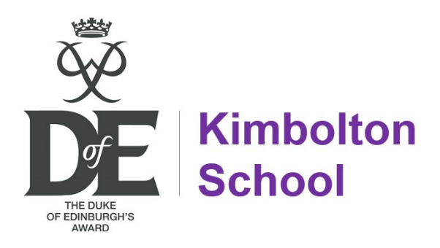

DofE Expedition Programme 2025
1st – 3rd April.
DofE Gold Expedition Training (LVI), Edale.

29th April.
DofE Bronze Expedition Training (III Girls), Kimbolton.
4th – 5th May.
DofE Bronze Expedition Assessment (III Girls), Kimbolton.

28th May.
DofE Bronze Expedition Training (III Boys), Kimbolton.
29th – 30th May.
DofE Bronze Expedition Assessment (III Boys), Kimbolton.

3rd – 7th July.
DofE Gold Practice Expedition (LVI), North York Moors.
21st – 26th August.
DofE Gold Assessment Expedition (LVI), Northumberland.

20th – 22nd September.
DofE Silver Practice Expedition (IV), Peak District.
30th October – 1st November
DofE Silver Assessment Expedition (IV), Rutland.

DofE Gold 26 (tentative dates):
Training 14th – 16th April / Practice 4th – 8th July / Assessment 21st – 26th August

